**Step 3: Plan the Solution (Algorithm)**

**Decision Logic Overview**

1. Initialize system, read current time from RTC.
2. At each feeding time:
   * Check food level sensor; if empty, send alert.
   * Check if pet is present (optional).
   * Rotate servo motor to dispense pre-set food portion.
   * Monitor weight sensor before and after dispensing.
   * Wait for pet to eat within a defined time window (e.g., 10 minutes).
   * If food weight in bowl does not decrease, send alert (food not eaten).
   * Update LCD display with feeding status and time.
3. Repeat for all scheduled feedings.
4. Standby mode when no feeding is scheduled.

**Flowchart:**

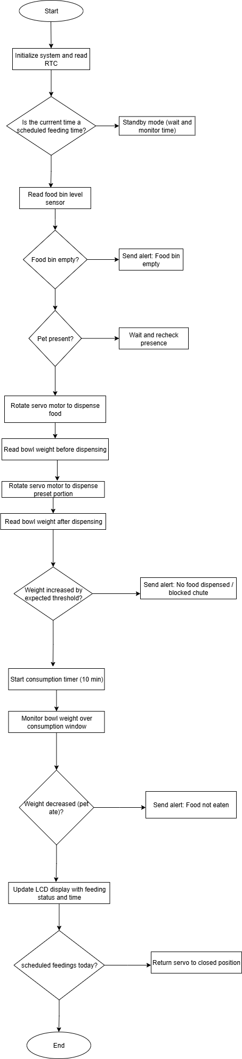

**Error Detection Logic:**

1. No food dispensed: Servo motor activated but weight sensor unchanged → Alert.
2. Food not eaten: Weight sensor weight unchanged 10 minutes after dispensing → Alert
3. Food bin empty: Food Level sensors trigger alert.